**DIRECTORS’ REPORTS FOR THE 2022 AGM (2021-22 ski season): Nordic Centre, Events, Membership**

**Nordic Centre Report**

The Nordic Centre continues to improve the trails, facilities and grooming to provide a great skiing experience for our members and visitors. In the last year, we hired a general manager, improved our trails, increased maintenance of our grooming machines, completed the new garage and added a sled shed.

General Manager  
Jan Wengelin is the club’s general manager. Jan’s primary responsibilities are to manage operations at the Nordic Centre but also supports our club’s volunteers and our efforts to obtain grants and sponsorships. Jan has been able to bring in a lot of improvements that result in our groomers being better supported and our machines and facilities better maintained. Feel free to contact Jan to learn more about what is happening, to provide your input and to enquire about volunteer opportunities at the club. [gm@bvnordic.ca](mailto:gm@bvnordic.ca)

Trail Improvements  
Due to the amazing generosity of our members, the Pine Creek trails are greatly improved, and we are no longer in danger of losing access to the back end. Last year’s fundraiser brought in $16,000 from individual donations and top-ups from Cross Country BC’s anonymous donors. As well, Bulkley Valley Home Centre donated $6,000 of bridge building materials. There was enough funding to install one bridge with a “permanent” structure (good for about 25 years). For the other crossing, local logs were added to the surface which will keep access open for a few years, and some of the materials for a “permanent” bridge are now at the site ready to install when we have the funding and a suitable work window. In addition, we fixed up the five km connector with culverts and a lot of ditching. This was the worst big wet area remaining on Pine Creek. As with previous years, the disturbed areas were seeded with grass to reduce erosion and brush. Kevin Kriese expertly led the planning and implementation of this work.

|  |  |
| --- | --- |
|  |  |

Another trail improvement was led by Kelsey Stasiuk. Some of our trails have stumps and rocky outcrops which can damage our equipment and prevent early grooming. The club rented a rock busting attachment for the skid steer for a short period. Kelsey then spent hours more on the skid steer removing those busted rocks and digging out stumps. Even his kids helped with the rock picking and stump/log removal, making mowing and grooming better/safer/cheaper.

|  |  |
| --- | --- |
|  |  |

In addition to these major improvements, our club’s volunteers have been mowing and brushing during the summer to keep our trails and roads ready for the snow.

The trail work done this summer probably won’t be noticed by most skiers this winter. But while you enjoy nicely groomed ski trails, know that below the snow there are safe crossings, and drier, smoother ground that was groomed earlier and better than they would have otherwise.

New Trails  
Planning continues on some new trails and will result in an updated trail plan later this fall. Some of the trail ideas are long-term concepts that will be subject to our grooming and maintenance capacity. The following are priority trail projects that are within our current capacity but subject to further discussions, consultations and formal trail authorizations. We also need to find sufficient funding:

* Swamp bypass trail. This is intended to replace a section of Pine Creek trail that was permanently closed because of a dangerous swamp crossing.
* Adventure trail – we hope to put in a narrow trail for kids through the forest near the lodge. A trail planning group has been working with other user groups to find the best location.
* Dog trail addition – field work and consultations are underway to hopefully allow a short addition to our dog trail network.

Buildings  
The Tracksetter Garage and Sled Shed are finished! They are great looking additions to our Nordic Centre but more importantly, they will allow us to take better care of the machines we rely on for Nordic skiing.

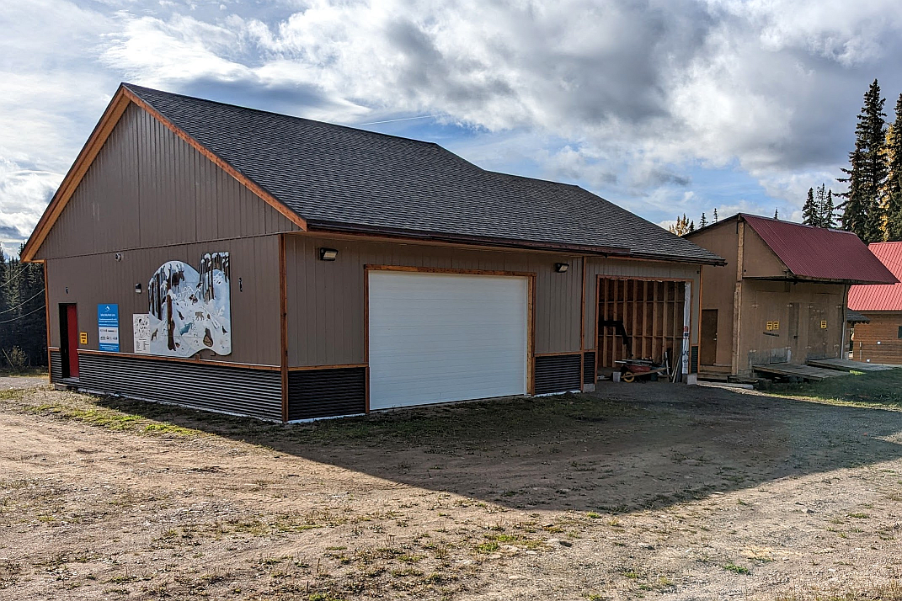

This was a multi-year project led by Steve Howard and Brant Dahlie and supported by many volunteers and great contractors. $245,000 of funding for the garage came from:

* Northern Development Initiative Trust $68,000
* BC Gaming Capital Projects grant $57,000
* Wetzin’kwa Community Forest Grant $15,000
* Brucejack Mines $5,000
* Seabridge Gold $3,000
* West Fraser Mills (in-kind contribution)
* Bulkley Valley Engineering (donated engineering services)
* 2020/2021 Club fundraisers for quad and garage
* BVCCSC funds (Allocations from the club’s sponsorships, savings and some program surplus. Check out the list of club sponsors on our [sponsors and partners webpage](https://bvnordic.ca/about-our-club/sponsors/).)

The remaining old shed is still needed for equipment and signs but the foundation is in rough shape. It has been braced to survive another winter and then we plan to replace the foundation next summer. The Regional District of Bulkley Nechako has earmarked $45,000 of gas tax funding for this upgrade.

Machines  
Here is an update on our machines. Jan is making sure that the necessary maintenance is carried out to minimize any downtime on these important machines. Day to day greasing etc. is done by operators but more significant maintenance and repairs are handled by heavy duty mechanics.

* PistenBully – our PistenBully Edge is well suited for our trails and snow conditions. Unfortunately, it is showing its age. We have owned it for ten years but it was built in 2004. This year’s post-season maintenance was extensive and costly. It is in now in pretty good shape and should work reliably this year and hopefully a few more. How long it lasts will depend on how much we use it. Ideally, we should buy a new replacement soon and keep our old one as a backup tracksetter.
* Planning for a new tracksetter – A PistenBully 400 costs over $450,000. A used, refurbished PB400 is around $250,000. The club is starting to explore grant opportunities, but large grants typically require the recipient to contribute 50% of their own money.   
  The Club used to budget $15,000 a year toward a replacement fund but that savings fund was not growing. For a number of years, we did not have enough operating surplus to make the full savings target. Frequently we had to dip into the fund to pay for “unexpected” major repairs. We now have a larger maintenance budget and a contingency fund for major repairs but no replacement fund. This year’s fee increase should help us start building a replacement reserve fund while we seek grants and other sources of funding.
* Tracked Quad – we purchased our tracked quad in the fall of 2020 with $22,000 from the club’s 2020, 2021 fundraisers. The quad had more power and traction than our snowmobiles machines and could be used in the summer (with tracks removed) for mowing and trail work. Unfortunately, we had increasing problems that eventually got traced to its electronic modules. We had it in for warranty service several times but when we heard that the modules were out of stock and not being manufactured anymore, we had to give up on getting it fixed. The local dealer, Evergreen Industrial, agreed to take the quad and give us a trade-in credit for most of the cost of the new Skandic snowmobile that we ordered last spring. The money contributed from members toward the quad has effectively been recycled into a new Skandic snowmobile!
* Skidoo Skandic snowmobiles – We now have two Skandics that can pull our small groomers (Ginzu, G2 and roller). The 2015 Skandic has been a dependable workhorse for years but now has enough hours to reduce its reliability. The new 2023 Skandic is currently being outfitted to tow our groomers.
* Skidoo Alpine Twin tracks – These utility machines are probably from the 1980s. They still run and often help with early season packing, trail maintenance and race setup.
* Taiga Nomad –Corry and Harvey Tremblay are donating an electric snowmobile to support a greener future. We are looking forward to receiving this snowmobile in February. The Nomad is being built in Quebec and the prototypes have good reviews. It is exciting to be early adopters of this new technology. The Tremblay’s want us to test its capabilities and let others know what we learn.

Internet  
Telus is supporting our community by generously covering the cost of extending their fibre optics cable all the way to the Nordic Centre. This winter, the club will have much better access to the internet for our grooming reports, webcams, training and events. Eventually, skiers might be able to have limited wifi or perhaps cellular access at the lodge and/or parking lots. Thank you Telus!

**Events Report**

**Summary**

The Club was delighted to resume a full roster of social events, clinics, and races for the 2021-22 season. The season kicked off with a coaching clinic for our Masters and Womxn's Clinic coaches taught by BVCCSC alumna Ingrid Granlin. A beautiful Holiday StoryWalk and whimsical Santa's Workshop kicked off the busy holiday season at the Nordic Centre. Despite the bitter cold, many members appreciated the beauty of this self-guided event. The popular Holiday Hustle was once again held but participation was down in large part due to the extended cold snap. Just after New Year's our Club was delighted to host its first “live” race in nearly two years, the Teck #2 Northern Cup. Robbie Dunbar took over the reins as the Club's Race Director, bringing excellent organizational skills and enthusiasm to the role. Later in January, the Womxn's Clinic provided a fantastic day of instruction to over 55 participants. The month wrapped up with a very popular Tour de Treat, wherein skiers were able to complete a loop of some of the Centre's favourite terrain, while visiting stations stocked with delicious cookies & pastries generously provided by local businesses and volunteers. All proceeds from the Tour went to our local food bank. In February, the Club hosted its second race of the season, the Chris Dahlie race & Teck #5 Northern Cup, which drew nearly 100 racers, including many masters. McBike's popular Family Day event was very well attended with many people enjoying free skiing and free rentals. The busy events season wrapped up in March with the 33rd annual Wetzink'wa Loppet. Unsurprisingly, attendance was the highest it had been in over a decade, with nearly 180 participants, including many from out of town. Combined with the Virtual Loppet, held the following week, over 270 people challenged themselves on a number of courses ranging from 1 km to 32 km long.

**Forecast for 2022-2023**

The Club is excited to be hosting its first Cansi course in over a decade. This course will be offered at minimal cost to our Masters and Womxn's Clinic coaches, which in turn will benefit our adult members. Preparations for many of our annual events are already underway. Our Club will only be hosting one Teck Northern Cup this winter. The Race Committee is planning to make it a weekend of racing at the end of February, with events planned for both Saturday the 25 and Sunday the 26. The Race Committee regrets that it will be unable to organize a virtual component of the Loppet for 2023. If this is something that you enjoyed & wouldn't want to miss, please contact the Events Director if you would like to take it on. Events at BV Nordic Centre would not be possible without the enthusiastic support of volunteers – please consider checking one of the boxes to volunteer during the registration process.

**Acknowledgments**

Club events are entirely volunteer driven. Events last season would not have been possible without the

enthusiastic contributions of Ingrid Granlin, Lea-Marie Bowes Lyon, Perry Rath, Ellen Anderson,

Christine Bruce, Kira Hoffman, Malcolm Johnson, Ally Dick, Theresa de Groot, Julie Sheppard, Sue

Harris, Liz Holdjk, Kaitlyn Bailey, Jill &amp; Peter Krause, Emma Hoffman, Andrew Pearce, Jen Plummer, Robbie Dunbar, Dean Allen, Laura Hols, Liza Hart, Mark Gillis and all of the many volunteers who pitched in at social events and races this year. THANK YOU!

Club events are entirely volunteer driven. Events last season would not have been possible without the enthusiastic contributions of Ingrid Granlin, Lea-Marie Bowes Lyon, Perry Rath, Ellen Anderson, Christine Bruce, Kira Hoffman, Malcolm Johnson, Ally Dick, Theresa de Groot, Julie Sheppard, Sue Harris, Liz Holdjk, Kaitlyn Bailey, Jill & Peter Krause, Emma Hoffman, Andrew Pearce, Jen Plummer, Robbie Dunbar, Dean Allen, Laura Hols, Liza Hart, Mark Gillis and all of the many volunteers who pitched in at social events and races this year. THANK YOU!

**Membership report 2021-2022**

2021-2022

Members 1238

Self serve ticketing (last cash out Apr 06/22)   $13218.35

Store sales  $8952.50

2020-2021

Members 1104

Self serve ticketing (last cash out Apr 24/21)   $17871.75

Store sales  $11085.00