Board members
Present: Rob Dowling, Barb Guillon, Anne Harfenist, Ali Howard, Malcolm Johnson, Kevin Kriese, Andra Nadeau, Sarah Newton, Torbjorn Rive, Sarah Sacharoff, Tammy Woods

Unable to attend: Adrianne Rosenberger

Guests: Kelsey Stasiuk

Meeting started at 19:05
1) Minutes of Last Meeting

Motion: Ali moved to accept the October 28 draft board meeting minutes; Sarah N. seconded. Approved.

2) Directors Reports – reports can be found at the end of these minutes

3) Action Items from Previous Meeting

- Ali, Sarah S., Sarah N. and Jan to prepare reports for AGM and send to Anne - done
- Anne to collate departmental reports and send to Sarah N - done
- Sarah S. to ask Sarah H. to send financial reports to Sarah N. - done
- Sarah N. to send all material for posting to Jack – done
- Anne to thank all those who responded to our call out for board members and introduce idea of committee at AGM; Sarah N. to further flesh out - done
- Sarah N. to post more information on super supporter pass - done
- Jan to send Sarah N. info on volunteers for next newsletters - done
- Sarah N and Sarah S. to check Safe Sport policy to see whether president responsible for safe sport -not done?

4) New/Continuing Business

- Signing Authority

Motion: Sarah S. moved to approve Barb, Ali, Rob and Tammy as signers on cheques; Anne seconded. Approved.

- Director Responsibilities table

Motion: Sarah S. moved to approve the 2025-2026 Director Responsibilities and Key Positions table; Ali seconded. Approved.

Action item: Barb to coordinate adding the new signers

- Nordic Centre priorities
- Division of roles – update Jan’s job description and director’s job description
- Capital replacement plan
- Lodge renewal assessment (e.g. kitchen, more lockers)
- Strategic approach to grants
- Update standards and protocols for grooming
- Although not a priority, there was discussion about tightening up the reporting of conditions on Nordic Pulse

- Feedback on early season opening sequence
- Board agrees that when the trails are safe to ski/conditions are reasonable and safe, should make efforts to open to all skiers – equitable access
- Official opening is when our liability kicks in
- Consider possibility of soft opening
- Consider if and when it is okay to have 2 classes of skiers

Action item: Kevin to return to board with draft policy

- Setting priorities for funding and grants for the season

- Possibility of club fundraiser discussed
Motion: Sarah S. moved that if CCBC sponsors club fundraisers, the board support a club fundraiser for $10-12K for the playground project; Tammy seconded. Approved.

Action item: Andra to set up club fundraiser

- Dog Trail Survey

- Results of second poll distributed prior to meeting
- Discussion repeated points raised during last year’s discussion
- Tabled

- Grant Tracking

Action item: Andra to move grant tracking spreadsheet and at least some grant-related folders in Grants and Sponsorships from board/admin directory so are available to non-board members

- Honouring people
- Request received to honour one of the early club members

Action item: Tammy to contact partner of potential honoree

- Dahlie award
- Present award at loppet rather than at AGM
- Run it by Brant

Action item: Malcolm to write up process for award

- Board email ownership
- Tammy to become owner

Meeting adjourned 20:50
Next board meeting:
Action item: Sarah S. to send around poll wrt availability

Directors Reports

Chair (no report)

Barb: Treasurer (financial reports posted on shared drive)

- Barb sent an email noting increased use of e-transfers for trail fees and other payments

Nordic Centre (emailed Dec. 9)

From Kevin:
1. We were officially open on November 19th, which is the earliest since we started recording. When we opened, we probably had the best Nordic skiing in Canada for the next two weeks (we got lucky with cooler conditions, and other places got the warm front). We had "unofficial" skiing in pretty good conditions for 10 days before we officially opened.

2. Jan and Kevin are updating roles for the GM and Director to reflect the evolution of the GM role that Jan and Steve initiated. The Director role will be more strategic, with the GM handling almost all day-to-day operations.

3. We did have one minor repair to the Bison in November that was covered by Warranty. Our Warranty expires in January, so we will start to see an increase in our operation budget. Even new machines sometimes have issues!

4. Looking ahead to the holiday season, we are very well-positioned with all systems ready to deliver excellent Nordic skiing.

From Jan:
- An amazing start to our operation season, thanks to all the work we put in on the trails. That work allowed us to mow into October and start packing snow as early as our first 10 cm when that arrived. All our priority 1 trails are well drained and grass seeded which helps tremendously to be able to work the snow early.
- We do have a well oiled group of keen Early Season small machine operators that knows what our goals are. No breakdown on machines also allowed us to stick to our plans and we never felt being behind on preparation of the trails.
  - Our Taiga Nomad electrical sled has been great with no issues
  - Our Skidoo Skandic was brought out to early and blew and suspension seals on front
  - Polaris Ranger Side by Side has proven to be our go-to work horse in early season preparation
  - Unfortunately our Roller will need serious repairs and most likely a replacement for next fall. The roller is old and takes incredible beating when preparing the trails with low snow.
- The Bison started to move almost 2 weeks earlier than 2024 which again made for very good conditions. Thanks to our dedicated Bison crew that now have a clear understanding on when to groom in various conditions. For 2026 season we have rnow each our cap of four operators. Until we get another Prinoth Bison we’ll remain at four operators.
- Our caretakers are very happy with the new windows and tin siding on the cabin. Already Gen noticing no moisture build up own the new windows and much better insulation.
- We have roped in one more Bobcat Plow operator (Nathan Huisman) to help support Miichel and Zach clearing our driveway and asking lots. With Michel around we now have three Bobcat Plow guys that take turns on clearing the snow. I still feel that we can use one more Bobcat plow person to ensure 100% flexibility when scheduling in their shifts.
- Talking about plowing, a shout out to Dawson Road Maintenance that continue to come up our driveway and help pushing our snow banks back.
- The lodge is running on its own and the newer heating and ventilation system is working out great. Gen is the person in charge communicating with the installer if anything goes sideways.
- Our Wax Hut is being utilized more and more and Gen is lighting the wood stove every Sat and Sunday when they are on the premises. Its great to see more usage and Andrea has done a great job wrangling athletes over to the Wax Hut.
- Our new benches and cubby wall will start being delivered this Friday. Have patience with the Mens Shed as they are limited in time and space. They’ll get ‘er done.
- As we all know the logging operation was thought to be a thorn in our sides, but with the good snow conditions we barely noticed the loss of some trails. Logging operations are now done and we start preparing the Demo Forest rd with any snow we receive.
  - Our plan now is to close the gap with snow between Broadway and Wetzinkwa trails so no need to take skis off, as well as closing the short gap between Demo Forest Rd and Valley View in the next day or so. That will give us good longer loops while we wait for Demo and Upper Logging trail to heal.
- We’re continuing communication and reaching out to parents via NSDP and SkiBoosters regarding toys left in the snow after being used. This really ticks off our Bison groomers as it not only add time but also cost maneuvering around, backing up and circling around left toys, never mind getting out of the snow cat (which is a huge safety concern)
Sarah N.: Communications (emailed December 8)
-Two newsletters so far this season, a third one will go out next week. Links are available on the BVCCSC website.
-Answering messages sent via social media.
-Helping Lea-Marie with Biathlon communication regarding programming & free ‘try biathlon’ weekend.
-In communication with CICK’s Dan Mesic for a community radio interview soon.
-emailed Interior News regarding submission of articles. In the past I have had very little success, and I have written them again this month asking for feedback on how to get articles successfully submitted.
-Created the Super-Supporter Sticker for season pass holders who chose that option.
-Wrote racer articles about autumn dryland and on snow camps that our young racers participated in.

-Created a series of social media posts about:
leashing dogs in the parking lot, through the tunnel
wildlife on the trails caution
picking up poop even if it isn’t your dog’s poop
logging closure updates
shopping locally at our sponsors
buying passes and womxn’s clinic sessions as gifts
helping with and attending Tour de Treat this December
Story walk updates
shout outs for volunteers for upcoming events
recognizing new board members
Recognizing volunteers for: brushing, construction, grooming, emergency pack shelter
Cautioning drivers to slow down in our driveway
Opening day updates
AGM invitations to members
Rabbit/Bunnies programming deadlines, additions, info

-Over two interviews with the Thursday Girls, I wrote a story about their friendship for the newsletter, sent to CCBC and Nordiq Canada. Thursday Girls Article

-Made three YouTube videos at BV Nordic to showcase our early season snow:
Dreaming of XC Skiing
A Season's Pass You Say?
What Would Alex Harvey & Devon Kershaw Say?

-Most importantly, purchased and installed Percy the Snow Cat:
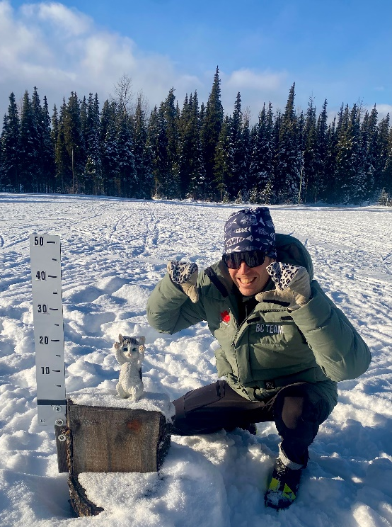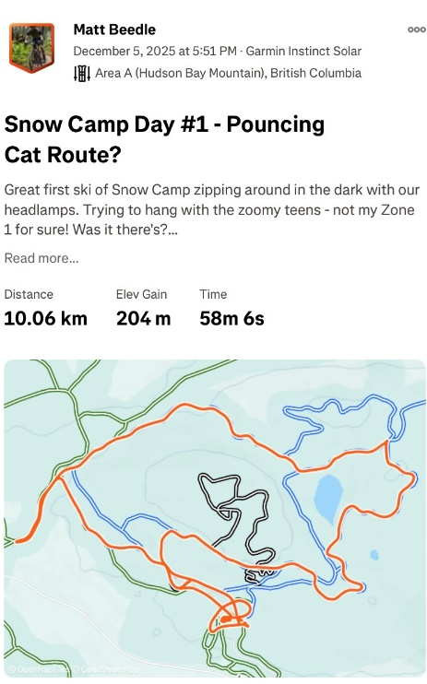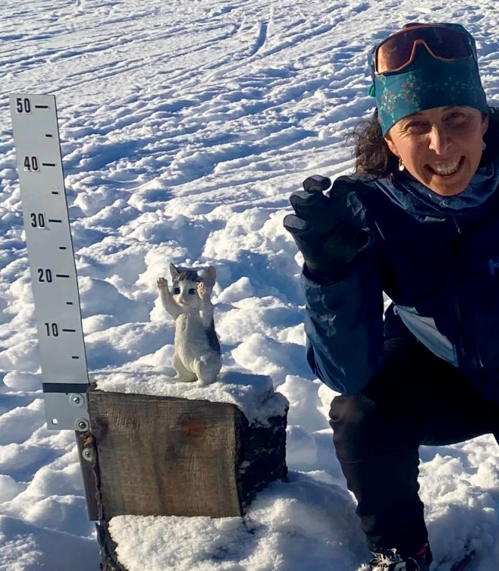

Race Planning Update (For BVCCSC Board Awareness). This is a Tabled Topic on the Agenda:
Roger McMillan & I are in ongoing discussions with Jeff Ellis, Nordiq Canada’s Director of Events. Our initial request was for homologation information to support long-term trail planning. Knowing what types of future events we host is essential for a long term trail development plan. Jeff is interested in including BVCCSC in future event planning. Specifically:
- Potential Western Canada Cup Inclusion: If Nordiq Canada launches a Western Canada Cup series—Jeff’s stated goal—our venue would be considered for inclusion.
- National Masters Series: Jeff encouraged us to consider creating a proposal for hosting events in the national-level Masters racing series. This would be a level higher from recent races we have hosted.
- Alternate Venue for National Races: He would like BVCCSC to serve as an alternate site for any national-level races assigned to Caledonia Nordic in Prince George. This would have been beneficial during the recent Olympic Trials relocation to Sovereign Lake Nordic.
Serving as an alternate venue provides several advantages:
- Our volunteers gain exposure to higher-level race operations, as the Caledonia race committee would collaborate with ours to co-host.
- BVCCSC would benefit from race fee revenue.
To proceed for next season, it would be valuable to secure pre-approval from the current BVCCSC Board to act as an alternate national-level venue. Any questions arising from that discussion can be addressed with Nordiq Canada well in advance of any emergency relocation request.
Grants & Sponsorships (no report)
Ali: Events (emailed December 9)
-- The race committee (RC) is working on the Teck Northern Cup #1 & #2 races January 3 & 4. This year #1 is also a BC Games qualifier for 2011/2012 age group skiers. There will also be the annual Dahlie Open for masters skiers. Based on the success of last year's exhibition team sprint, the RC is planning to offer one again this year. It will once again be an exhibition race, as the RC is hoping to work out some registration quirks, etc, before making it a sanctioned race. Robbie Dunbar is once again heading up the RC.
-- The Tour de Treat on Saturday, December 20 should be well-attended. Posters are up around town and volunteers are almost totally subscribed. Sue Harrison & Kate Kantakis are once again organizing it and have things well in hand.
-- The Holiday Hustle is in limbo unless volunteers step in. I have reached out to a few people who have very enthusiastically taken part over the past few years and hope to hear from them soon. Jan & the grooming team have requested a specific course due to the logging, so the organizer doesn't even have to plan the route.
-- Planning for the Womxn's Clinic, Sunday January 25, is well advanced and registration is open. Last year's organizers, Abby Morgan & Julie Sheppard, have once again taken it on but were recently joined by Laura Kroesen, who has agreed to help again next year so there is a succession plan should Abby & Julie step back (likely, especially since this is Julie's 4th time making the event a success!)
-- Still seeking an organizer for Welcome Day. I have reached out to a few people, but have yet to hear back.

Sarah S. & Adrianne: NSDP (emailed December 7)
Rabbits
- Some discussion happening between head coach, rabbits coaches, NSDP directors about what skills should be taught in rabbits, what age groups. Some concern from rabbits coaches about too big a skills/commitment jump to Track Attack. Andrea to make clear guidance to rabbits coaches regarding this.
- CC course was instructed by Andrea and well attended by BV coaches
- Considering strict requirement on rabbits/bunnies coaches to have taken the CC course for next year. Will improve the overall rabbits program by preparing coaches with lesson plans and clear goals on what skills should be introduced when. Also will give Rabbits coaches a better understanding of the overall youth progression through our programs
- Plan in the works to have a rabbits coach meeting in mid December with Andrea and NSDP Directors
- Early plan in the works to have a rabbits all-parents zoom meeting in the week before Rabbits starts
- Had some confusion about the start time of bunnies/rabbits for this year. Registration and website were not in agreement. Our understanding is that this has been resolved.
Build the North project
- Sarah S working with Sarah Hagen to figure out the best way to account for this project in our books without inflating our income. 28k coming in of which only a few thousand would be for BV
- Finlay PG seems to be making lots of connections with other local clubs. Sarah S had Ft Nelson contact her about grant writing advice
Fundraising / Grants
- Kal Tire grant will now be used for cartoon character signs for bunnies/rabbits in the skills park rather than for an athlete coach. The athlete coach became unavailable.
- Nationals parents have Bugwood Coffee Fundraiser underway, decided against a Tortierre fundraiser
- Ski Swap went very well. Was able to sell some of our fundraiser coffee there.
- Applied for BVCF ski skool grant for the 2026-27 season (not this year but next)
- Sarah S found an issue with the ski skool financial report we sent BVCF in June for the previous season. Fixed the report and sent with apologies to BVCF.
- Would make sense for Sarah and Adrianne to connect with new Grants/Sponsorship director to give a bit of an NSDP grant braindump, understand who is responsible for tracking, reporting, etc.

Programs:
- Snowcamp happening Dec 5-7th.
- CCBC provided coach Zach Hill
- Went very well with 88 athletes and over 20 coaches attending.
- Had clubs from Terrace to 100 Mile attend
- Very well executed due to numerous dedicated coaches and volunteers.
- ADP Programs running well
Ski Boosters:
- Georgie Watts held orientation at the lodge for new ADP parents on how to do lodge duties
- Worked with Jan to understand new requirements for cleaning solutions so as not to kill healthy bacteria in septic system.
- Adjusted the cleaning shifts for race weekends so ADP will do a restock (not a full cleaning shift) on the Thursday or Friday before a race to make sure the bathrooms and garbages are in good order. In addition, after the race we will do a full clean. What we are asking race committee to do is to check the bathrooms every once in a while during a race day or race weekend. It probably doesn’t need to be its own job and could be added onto another role but Ali would know best. ADP will look after the before and after.
Ski Skool:
- As usual we need more coaches. Melissa is planning to send some club wide correspondence about this
Safe Sport Policies on Website:
- There seems to be something wonky going on with the safe sport policies on our website. When Sarah S looked at them the pages seem to be not in order and some even missing. Sarah S took a quick look to try to fix but it wasn’t a quick fix. Something to do with the conversion of the files to .pdf they were corrupted. The original .docx files seem fine. This needs to be done by someone. Jack, the website guy, although board drive access is required???
Anne: Secretary (emailed Dec. 5)
- Submitted Annual Report to RSTBC
- Submitted Financial Report to RSTBC
- Submitted Annual Report to BC government

