Board members
Present: Jen Chapman, Barb Guillon, Anne Harfenist, Ali Howard, Courtney Maricle, Steve Osborn, Joanne Reid, Adrianne Rosenberger, Sarah Sacharoff

Unable to attend: Sarah Newton

Guests: Jan Wengelin

Meeting started at 19:05

1) Minutes of Last Meeting

Motion: Barb moved to accept the January 29 draft board meeting minutes; Joanne seconded. Approved.

2) Directors Reports

Jen: Chair (no report)

Barb: Treasurer (financial reports posted on shared drive)

Steve O: Nordic Centre (emailed Feb 22)

Nothing special to report about the Nordic Centre.

Sarah N.: Communications (emailed Feb 17)
Newsletter
Working on the 2nd newsletter for the month of February. There are so many wonderful things going on with our club that they are a joy to write. Thank you for everyone who is submitting content and providing feedback.

Continuing to post the newsletters with a hard copy in the lodge, and to be used for social media and website updates as the season progresses.

Direct Correspondence
With extensive direction from the Chair and other board members, I have coordinated correspondence with two club members regarding a harassment claim.

Newspaper
Submitted another article to the Northern Interior News. It is proving challenging to get articles published. This is the 3rd one this season. I have tried polished articles, point form updates and press releases. I just wrote them a follow up today to ask what I should do differently to get our information published. I believe I am a decent writer, having had numerous articles published in Revelstoke and Fort St. James. Stay tuned.

Photography
I am continuing to expand our file of non-identifiable but interesting images for social media and general communications. As well I have been collecting images that have permission provided.

Stickers
Yes, I have been working on stickers and recently asked Kristen Charlton, one of our members, to create a few designs. I sent off the suggestions to Ava Wimbush to get a youthful eye on them too. Very soon I will have a few designs for the board to discuss.

Courtney Maricle: Grants & Sponsorships (no report)
Ali: Events (emailed Feb 23)
February 8 & 9: Teck Northern Cups 1 & 2 and Chris Dahlie Open and Exhibition Team Sprint
-- well attended by club members but only 14 out of town racers attended (19 had registered); 82 participants day one, and 74 day two.
-- race committee (RC) was very pleased with how exhibition race went and participants were also glad to take part in a race with a teammate
-- new V-boards purchased with surplus DDF money made course and stadium set-up, especially, much more straightforward than in previous years. The lap lane and finish lanes were easier for participants to navigate as they were different colours and extensively marked. Big thanks to Steve Osborn for allocating the necessary funds
February 16: McBike Welcome Day
-- over 130 people attended, man of whom had never skied before
-- huge thanks to Jill & Peter Krause of McBike for giving up their rare long weekend to bring their rental fleet so people could use it for free
-- Smithers Community Services Association brought about 40 people, including their own great volunteer fleet, to enjoy the day
-- will continue to seek out individual(s) to take on this event as it could become a flagship event for the Club, in terms of community building and goodwill
March 15: Annual Loppet
-- weather permitting! Second early thaw has possibly dampened (literally!) people's enthusiasm
-- RC beginning to plan the event, and will plan for about 275-300 participants
-- registration not yet open but volunteer sign up is; race committee will once again give away a season pass for 2025/26 to one lucky volunteer
Sarah S. & Adrianne: NSDP (emailed Feb 19)
Rabbits
- Had a night ski
- Chris Dahlie caused Rabbits cancellation. Apparently Tara MacPherson encouraged rabbits to race on the Sunday. Not sure how that went.

ADP
- 13 ADP athletes went to Ottawa for the Nakkertok exchange. They had a fantastic, fun filled time. We absolutely strongly recommend that ADP do this again in three years. Would recommend doing it with Nakkertok again as they are very experienced and will be excellent hosts.
- ~9 BV Nordic Athletes attended Westerns in Kimberley
- ~45 BV Nordic Athletes attended the Prince George BC Cup last weekend. Was exciting to see a large contingent of U8-U12 athletes from BV Nordic.
- A couple of cold weather cancellations
- 4 U16/18 athletes attended a BC Ski Team camp in PG prior to BC Cup. Only 10 athletes total with 2 Ski Team Coaches.

Nationals
- In Canmore. Expecting about 10 athletes to attend. These athletes will be responsible for their own expenses as well as a portion of about $1600 of Andrea’s.

Masters Drop In
- Last session this week

Coaches
- Planning to have four coaches L2T Certified in advance of BC Winter Games 2026. CCBC invigilator coming from PG, Feb 22
- Nov. 28-30, 2025 – Community Coaching - Confirmed

Ski S’kool
- Awarded the BVCF grant for $6500 - Denise and Sarah will attend awards ceremony Feb 18
- Some cancellations due to weather but Denise has been able to reschedule them all.
Wax Team
- Determining if wax team will be able to wax skis at loppet. Key members will be at Nationals
- Potentially purchasing two more sets of test skis for testing liquid wax (new)

Wax Room during Practice
- Received a complaint from Kevin about athletes leaving their gear in a mess in the wax room during practice. This isn’t the first time we have heard from him about the wax room during practice. Sarah and Ben’s recollection is that he would also like the top surface of the cubbies left clear for wax kits, not gear bags. Andrea will communicate with athletes about the fact that the wax room is a shared space, not just ADP’s, and athletes need to leave their gear tucked away as much as possible while at practice. There are times when we have 160+ athletes all training at the same time so it is unlikely that our wax room will ever have enough cubbies even if we were to renovate. I think we can go a long way to making this problem go away by just tidying.
- Adrianne will explore some improved storage solutions in the spring when we are less busy.

Catering

- Received a concern about the food safety protocols not being followed by our ADP catering. This is legit. We need to have someone with food safe training involved in our catering. Yeva (ski boosters coordinator) is looking into what training our parents have. Yeva, Adrianne and I are looking into this for the loppet. Specific ways we are not being food safe: tracking fridge temperature, cooking some of the food in home kitchens and not at a food safe kitchen, sanitation (our dish station setup is not food safe). NSDP would absolutely pay for ADP parents to take course. Will work with the Race Committee/Events to communicate if we can fulfill loppet commitment safely.

Ski Playground

- Talked to Roger and Kevin. Sounds like there is interest but no champion with the time to make it happen anytime soon. I think that translates to “we are not ready to look for funding”.

Financials
- Currently predicting a balanced budget. Still some unknowns (summer registration, final program expenses, ski skool numbers, catering final numbers, etc)

Anne: Secretary (no report; membership report sent by Laura Feb 23)

2025 01 27 Membership Report
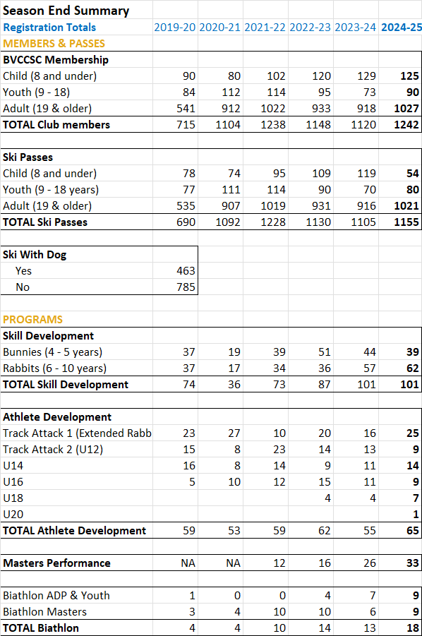
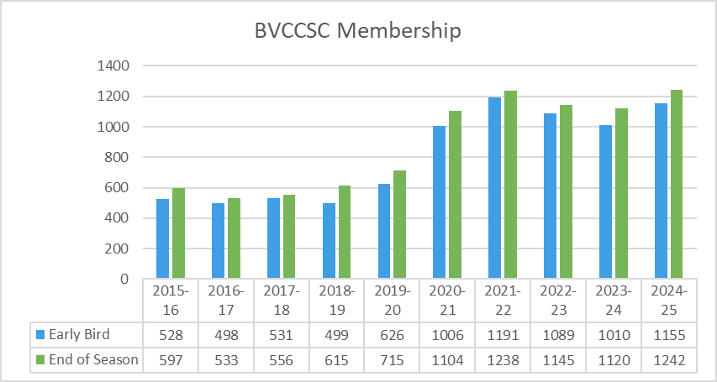
Joanne: (emailed Feb 19)
- signed the necessary documents for account transition as of February 18, 2025.
3) Action Items from Previous Meeting

- Jan and Jen to ask ICBC about PB insurance on road crossing - done
- Steve and Kevin to incorporate comments and present board with final trail plan for approval – done
- Adrianne to check on limits to reserve funds allowed for gaming grant - done
- Anne to write solicitation for sponsorship coordinator for newsletter - done
- Anne to write to Miller to accept BCGEU offer - done

Motion passed by email vote: Anne moves to add Courtney Maricle to the Board of Directors; Barb seconds. Approved.

- Tabled: Director vacancies: President, Treasurer – prior to next season

4) New/Continuing Business

- Recognising supporters (document circulated by email Feb. 17)
- No issues were raised

- Trail Plan
- reviewed some of the changes
- importance of playground for young kids stressed; needs champion
- premature to start in on playground without a leader

Action Item: [unassigned] call out for playground champion on social media and in next newsletter
Motion: Steve moves that the Board of Directors approve the Trail Plan 2025-2029; Jen seconds. Approved with 1 opposed

- Loppet

- Board supports closing trails on day of loppet up until 2 p.m.
- Advertise closure well in advance

Action Item: Ali to send email to all dog skiers to alert them to dog trail closures

- Updated Financial Management Policy

Motion: Steve moves that the Board of Directors approves the Feb. 23 2025 version of the Financial Management Policy; Anne seconds. Approved with 1 abstention.

Action Item: Steve to post updated policy on website.

Action Item: Sarah, Steve, Adrianne and maybe Steve W. to form group to figure out where club is in relation to Gaming Grant eligibility.

- Director of Operations vacancy – next step

- Had no responses via feedback to our email advert
- In interim, need to rely more on Jan; Jan will be more actively engaged
- Jan will report to board
- Put Jan on board email list
- Prepare list of “what does club with no operations director look like”
- Work with Sarah N. on wording then email & put on social media and website
- Hear from Jan and then discuss in camera
Action Item: Anne to solicit ideas from other directors and pass on to Sarah for wordsmithing and posting on website and social media
- Division of donations received via the registration form
- Divide 1/3:1/3:1/3 between NSDP, events and operations
- Idea of Welcome Day as significant event with budget allocated raised – put in next year’s budget

- Additional responsibilities for bookkeeper
- Next operations director not expected to take on financial structure
- Including producing year-end financial statements; provide advice to board wrt accounts; be proactive; track upcoming requirements like RD will need CPA-prepared financial statements in years 2 & 3
Action Item: Steve and maybe Barb to discuss expanded role with bookkeeper

Meeting adjourned 20:45
Next meeting: mar 31

