**Board members**

Present: Jen Chapman, Barb Guillon, Anne Harfenist, Ali Howard, Sarah Newton, Steve Osborn, Joanne Reid, Sarah Sacharoff

Unable to attend: Adrianne Rosenberger

Guest: Jan Wengelin

Meeting started at 19:05

**1) Minutes of Last Meeting**

***Motion:* Barb moved to accept November 25 draft board meeting minutes; Jen seconded. Approved.**

**2) Directors Reports**

**Jen:** Chair (no report)

**Barb**: Treasurer (no report)

**Steve O:** Nordic Centre (emailed Jan 7)

**Grooming**

All is good. Skiers are happy. The Prinoth Bison is working well.  Patrick and Kelsey are doing most of the grooming and really like their new machine. Cam Schley is building his knowledge and experience in the Bison.  Jan selected Geoff Recknell and Sean Fraser as Bison trainees with the goal of having them qualified in future.

Now that we have enough snow, there is less need for the volunteers on our small machines. They are still used for the adventure trail and occasionally to refresh skate lanes. The electric Taiga has done well this year except for some persistent software issues. In mid-January, a Taiga technician will be here at no cost to us to repair our machine (and machines at a few other BC ski areas).

The new Ranger has proven itself to be very useful and dependable. It is the best machine in some situations and not as good as the snowmobiles in other situations.

Our 20 year old PistenBully has been sold to Jim Simonelli for $35,000. He also bought our 2015 Skidoo Skandic for $1,000. (It has not been used since early last year due to fried wiring and major engine issues).

**Signs**

Jeremy Penninga (our new sign guy) installed new maps signs and new signs for the adventure trail. He ordered several information signs including a Crowned Dog (Dogs have right of way) and Keep Right (for the curvy hills on Wild Dog and Perimeter). He will install them soon.

**Idiots**

On New Year’s Eve, a couple quads or side by sides entered from The Way Home, tore around on N Lights, Hilltop, Down & Out and Broadway, then exited onto HBM Road. Kelsey repaired the trail surface right away, so no permanent damage, but it was sickening to hear of it.

On December 20, I discovered that someone took down the "No Dogs Allowed" signs at Pine junctions B and H as you enter Pine Mid Loop. They were not knocked down. Unbelievably, someone brought tools so they could unscrew one from a tree at H and unbolt one from a post at jct  B.  New signs have been ordered.

**Silliness**

Today, Gen Perkins informed me that she ran into some people skiing with dogs in the wrong direction trails and they told her that the policy had changed in the newsletter.

We are now communicating that "dogs have right of way" and it seems to be interpreted that dogs can go any which way???

Do we need to change our policy and/or messaging and not-yet-installed sign?

**Gaming Grant for Equipment Shed Upgrade**

We have been awarded $26,208 in funding for the Equipment Shed Upgrade and FireSmart project. (Note that this news has to be kept confidential until Gaming makes a public announcement.) The total project cost is $52,416 based on a quote from Glentanna Construction. Our 50% contribution is budgeted to come from a club fundraiser ($10,000), Nordic Centre Operations (at least $7,000), Infrastructure Reserve (up to $9,000).    
Kevin Kriese is willing to take on oversight of that project this summer but hopes the board can find someone to administer the club fundraiser.

**Destination Development Fund Project**

Some of our expenses were over budget and some under budget with the result being that we will meet our basic deliverables and still have with around $15,000 of DDF funds unspent (~2% of the total grant).

Although we could continue some of the trail work into next summer, I am very motivated to spend all of the DDF money before spring. Once we spend all of the DDF funds and submit a final report, they will release the 10% holdback  ($76,545) and we can avoid some challenging cash flow.  I requested and received approval to add the following as eligible to be paid with DDF money (the total estimate is greater than the surplus available to provide flexibility to match remaining money with new purchases.)

1. Tiller lights and camera for the new groomer  ($2000)
2. Training of groomer operators and local mechanic ($5000)
3. Replace tattered provincial flags for the lodge ($700)
4. Event fencing/dividers ($5,000)
5. Replace old, ill-suited mowing attachment (for trail brushing) ($10,000)

Note that the board previously allocated $22,648 towards trail improvements related to the DDF project but not needed for the basic DDF deliverables.  That money ($3,043 from last year’s club surplus plus $19,605 interest earned on DDF deposits) does not have to be in the DDF final report, so it is appropriate to earmarked for trail assessments, and improvements for next summer.  DDF is OK with us expanding the project beyond what is covered in the Final Report.

Note of interest: we committed in our original application to contribute up to $55,000 towards the groomer and $12,400 in kind (culverts, etc.). We have not had to use any of our club funds for the DDF deliverables because the DDF grant was based on a budget that included 15% contingency which turned out to be more than sufficient. I have been assured that we don’t need to show we spent any of the budgeted club money, as long as we can show we spent the DDF money and met the deliverables.

**Trail Plan**

The trail plan is currently being updated. Kevin, Roger and I would like to review the plan with the board at the late January board meeting. We will make recommendations on next steps for the overall plan, the proposed race route additions, playground improvements and proposed new trails. (We may have a project leader if the club wants to proceed with the new dog trail proposal.)

**Sarah N.:** Communications (emailed Jan 7)

-Early January Newsletter going out this week

-Newsletters being posted upstairs in the lodge

-January 2, sent article submission a second time to the local newspaper to see if they will publish it

-Working will with Jack and Carina for social media posts

**Grants & Sponsorships**: position open

**Ali:** Events (emailed Jan. 8)

**Completed Events**

Holiday events at the lodge were very well-received. The StoryWalk, generously loaned by the Northwest Child Development Centre, delighted skiers. The Tour de Treat on December 21 sold out and the Solstice event, also on December 21, was wonderful and well-attended. Special thanks to Sue Harrison and Erica Haughland for marking the solstice in style for our members. They worked tirelessly so others could celebrate.

The Holiday Hustle was again popular, especially as the big prize this year was a Nordic Ski Lab all-access pass courtesy of our club winning the CCBC membership contest again this year. Thanks to Brandin Lilgert & Malcolm Johnson for course set up & tear down, and to the Sacharoff-Forsyth family for tracking participants.

**Upcoming events**

The Womxn’s Clinic on January 26 is fully subscribed and has a long waitlist. Excellent work by Julie Sheppard & Abby Morgan to open registration ahead of holiday gift giving.

McBike Family Day on Sunday, February 16 has the possibility to be an excellent outreach opportunity for the club, given the number of people new to skiing, and indeed to Canada, who attend. I am actively looking for someone to take this on.

**Race news**

Six members from BVCCSC, and one from Omineca, attended the Level 2 Officials course held at the lodge Nov 30-Dec 1. The course fees were paid by a grant from ViaSport.

The RC is working on the upcoming  Northern Cup 1 & 2 and Chris Dahlie Open February 8 & 9 and looking at the possibility of including a team sprint. Exciting times!

**Sarah S. & Adrianne:** NSDP (emailed Jan. 4)

**Registration Update**

Rabbits - 100

ADP - Junior - 31

TA - 33

Masters Lite - 16

Masters - 16

Biathlon Masters - 8

Biathlon Youth - 9

**Rabbits**

* Starting up January\
* Coaches had a training session with Andrea Dec 29
* Need to figure out how/if rabbits are participating in the Chris Dahlie.
* Purchasing bv nordic headbands for Rabbits coaches that do their prescribed training courses (although they likely can’t do CC this year).

**ADP**

* older ADP athletes volunteered at Tour de Treat staffing the treat stations
* first race of the BC Cup series happening next weekend
* athletes have started tracking their km on the chart at the lodge
* Through Andrea’s persuasion, northern development squad athletes including (5 BV NOrdic kids) were invited to join BC Ski Team for a camp in PG prior to Feb PG BC Cup.  Yay Andrea!
* ~7 BV Nordic Athletes attended the Canada Cup in Vernon in early Dec

**Masters Drop In**

Andrea planning to offer a coaching session for Masters drop in coaches on Jan 19.

**Coaches**

* We are unable to offer a CC course in Smithers this year because of no instructor availability.  Working with CCBC to ensure this doesn’t happen again next year
* Held a T2T On Snow Course Dec 6-8 with 4 BV Nordic Coaches in attendance as well as 3 from other clubs in the North.  Billeted these coaches and the instructor Maria amongst BV Nordic families.

**Ski S’kool**

* Applied for BVCF Grant for $6.5K.  Should hear sometime soon.

**Snow Camp**

* Largest ever. Was super fun and went very well despite the large numbers
* Added a lunch as well as the usual dinner.  Food was well done and very much appreciated by the athletes
* Having TA and Juniors on a different schedule made it easier to accommodate everyone's needs
* Had a visiting CCBC coach come up to offer expertise to the camp

**Nakkertok Exchange**

* Hosted 33 Nakkertok athletes and 4 chaperones second week of December
* Did many fun activities around town to showcase Smithers
* Sock fundraiser was very successful
* Visiting athletes and chaperones were blown away by our mountain and our club.
* We had fantastic support from other community organizations to pull of this memorable week.  Curling Club charge us only $100 for a morning of curling for 33+ kids with instructors, Hudson Bay Mountain was very accommodating and let us use their school group rates.  Rotary gave us more money than we asked for….
* Organization of activities was split by day and shared by all the parents.  This worked well

**Google Drive Privacy**

* Sarah undertook an effort to reorganize our NSDP google drive and our drive permissions to ensure that we are keeping personal information private.  Did this through the use of google groups, rather than individual permissions on files.  This will be more maintainable.

**Handbook and NSDP Policy updates**

* Adrianne, Andrea and Sarah made some small revisions to the Handbook and ADP Race Travel Policy.  Will be releasing new versions very shortly and sharing with parents.  Changes specify that athletes needing a chaperone that isn’t the head coach at races, head coach always gets their own room, only non flouro wax, etc.

Other notes (Sarah S):

* Have heard lots of rave reviews about the grooming conditions.  Nice work grooming team.
* Had a couple of people stop me to tell me how fantastic they felt the Solstice Event was.
* At the curling club, saw that they have a poster with a list of club wants.  Things like “new coffee machine”, “folding tables”, etc.  There were about 10 items on that list and 3 or 4 were crossed out so it must be working.
* Some complaints from parents doing ADP duties about the vacuum in the lodge and its lack of effectiveness.

**Anne:** Secretary (membership report sent by Laura G. on Jan 8)

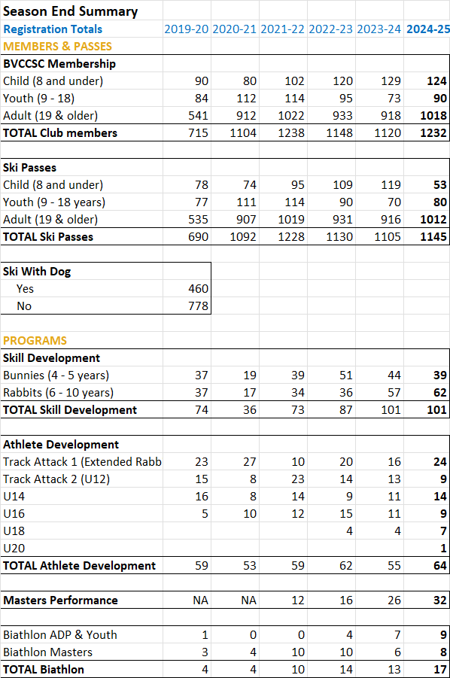

**Joanne:** (no report)

**3) Action Items from Previous Meeting**

* *Aurora to clarify with Jan about possible “expectations” - ??*
* *Anne to contact Aurora to obtain updates from her time as director of sponsorships and grants - done*
* *Adrianne write up call out for volunteers for screening committee for next newsletter - done*
* *Ali will speak to potential grants and sponsorship coordinator - done*
* *Jen to organise taking over signing authority – n/a*
* *Tabled: email votes (in general)*
* *Tabled: Director vacancies: Treasurer – prior to next season*
* *Tabled: free season’s passes for groomers*
* *Tabled: recalculate what our targets for reserves are*

**4) New/Continuing Business**

1. Using photos of members on social media & other communications

* For now, leave kids off social media
* Letter to parents of rabbits and ADP to ask if okay if photo taken from back
* Ask next year in registration

***Action Item: Sarah N. to send letter to parents***

1. Gaming Grant

* Discussion of other storage options
* Board supports going ahead with project
* Need to match funding: Original plan was $10K from fundraiser; $9K from Infrastructure reserve; $7K from NC Operations
* Discussion about whether to run fundraiser for this project
* Need someone to administer fundraiser

***Action Item: Steve to ask grant-writing volunteers if will administer fundraiser***

***Motion:* Steve moved to proceed with the shed upgrade project with 50% contribution coming from NC Operations and Infrastructure Reserve; Anne seconded. Approved with 1 opposed.**

***Motion*: Jen moved that if find someone to lead a fundraiser, club has a soft fundraiser with target of $10K; Sarah N. seconded. Approved with 1 oppose**

1. Destination Development Fund

* Board supports using last of the DDF $$ on some or all of the proposed items: tiller lights and camera; training; flags; event fencing; mowing attachment

1. Pine Creek 5K

* Interest in having 5K connecting bit groomed has been expressed by some skiers
* Even though only ~300 m, would be expensive and time consuming because of need to PB to backtrack
* Suggest use snowmobile to run through on occasion if already in area; no sign change

1. Dog Incident

* Owner of aggressor dog to receive written warning: extra vigilance, not proceed through tunnel if other dog in tunnel, muzzled

***Action Item: Anne to write letter to complainant and target owner***

f) Director of NC Operations

* Focus on this vacancy prior to others
* Social media posts and dedicated mail-out to members to emphasize importance

***Action Item: Anne to send Sarah N. job description***

g) President

* Wait in order to not distract from NC Operations

h) Insurance

* Bison covered on road crossing for damage, not liability
* Have liability insurance thru CCBC on paper but advised that element of risk that claim might be denied because no ICBC coverage

***Action Item: Jan and Jen to ask ICBC***

Meeting adjourned 21:10

Next meeting: January 27